TO: North Texas Soccer Presidents Cup Teams,

FROM: Jim Mills, Youth Commissioner

DATE: January 20, 2023

RE: 2023 North Texas Soccer Presidents Cup

Students Name:____________________________________________________________

On behalf of the North Texas State Soccer Association, we request the release of all players that are members of the 2023 North Texas Soccer Presidents Cup teams from your school to participate in our events March 8th – 12th in Richardson, Texas. We realize the importance of a player’s education and strive to accommodate the academic calendar as much as possible. Still, due to the number of teams in this year’s event, we need to play on Wednesday, Thursday, and Friday evenings. Regrettably, our schedule may affect some students because we need to schedule games starting at 6 pm on both days in Richardson, TX. While this would likely only impact a team on one of the days, it may mean an early release to make the drive.

As the State governing body for North Texas and the representative for US Youth Soccer, a national governing body for youth soccer under the United States Soccer Federation, this event qualifies teams to the US Youth Soccer Regional Presidents Cup and potentially to the National Presidents Cup finals in Wichita, Kansas. This program has been developed to allow our teams to compete against the best teams in the country. In addition, this provides a wonderful opportunity for players to showcase their talents in front of numerous college coaches at each level of this competition.

Thank you for being so understanding in regards to the absence of North Texas Soccer Presidents Cup players from school during this event. Please feel free to contact me with any questions. I can be reached at [jmills@ntxsoccer.org](mailto:jmills@ntxsoccer.org) or 972-977-7667.

Sincerely,

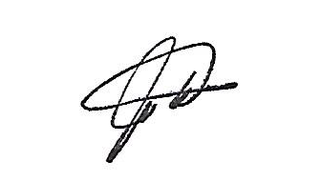

Jim Mills

NTX Soccer Youth Commissioner